1. Derive the minimum SOP expressions for each of the Karnaugh maps below.

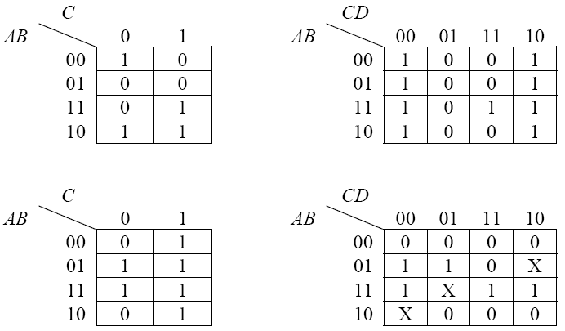

2.

Create K-maps for each of the truth tables below:



|  |  |  |  |  |  |  |  |  |  |  |  |  |  |  |  |  |  |  |  |  |  |  |  |  |  |  |  |  |  |  |  |  |
| --- | --- | --- | --- | --- | --- | --- | --- | --- | --- | --- | --- | --- | --- | --- | --- | --- | --- | --- | --- | --- | --- | --- | --- | --- | --- | --- | --- | --- | --- | --- | --- | --- |
| AB\C | 0 | 1   |  |  |  | | --- | --- | --- | | AB\C | 0 | 1 | | 00 | 1 | 0 | | 01 | 0 | 0 | | 11 | 1 | 1 | | 10 | 1 | 1 |  |  |  |  | | --- | --- | --- | | AB\C | 0 | 1 | | 00 | 1 | 1 | | 01 | 1 | 0 | | 11 | 1 | 1 | | 10 | 0 | 0 | |
| 00 | 0 | 0 |
| 01 | 1 | 0 |
| 11 | 1 | 0 |
| 10 | 0 | 1 |